MEMORANDUM

To: Peter Casey, DDOT

From: Garrett Eason, Chris Broll, Shilpa Rajbhandari

Date: August 18, 2018

Subject: Analysis on Light Outages and Crime

**Introduction and Methods:**

This project sought to exploit a kind of natural experiment in the District of Columbia by examining crime in close proximity to street lights before and after they have been repaired. The simplest analysis we could conceive to justify further study was examining crime the week before and the week after a repair. This required: (1) geocoding the crime data; (2) geocoding lighting data; (3) using a buffer 1/4th of a city block in radius around each light; (4) joining the lighting data polygons with the crime data surrounding each light for the week prior to and following the repair. Our first analysis considered a standard statistical difference in means, with following analyses considering conditional means and difference-in-difference estimates.

**Hypotheses:**

* Crimes committed at night will have a higher probability of occurring when a streetlight is out in contrast when a streetlight is functional.
* Different light density clusters across DC will carry different effects for light outages across crime, or more generally, different conditions will exhibit different effects for light outages on crime probabilities.

**Results:**

After analysis, a statistically significant (but economically insignificant) result was produced for the first hypothesis, with the second result producing statistically insignificant effects. Said differently, light outages were found to significantly impact crime occurrence probabilities generally, but this estimate is economically insignificant. Conditional estimates for different D.C. Wards, the number of arms on light posts, and types of crime were found to be generally insignificant and considering daylight crimes was found to be a poor control as repairs happen during the day.

**Evidence of Significant Effects:**

To support our results, it was estimated that the difference in unconditional crime occurrence probability 10 days before and 10 days after any light (in areas where crime was plausible) was repaired is approximately .12 percentage points with a t-value of approximately 3. Restated, the probability of a crime occurring in the area of a light outage was measured to be approximately 1.41%, while the probability of a crime occurring in the same area after the light was repaired was found to be approximately 1.29%. While these results are statistically significant, it should be pointed out that this estimate is too large due to the filtering of light posts in our data and because it likely exhibits endogeniety bias as shown by considering different windows of time. In summary, our estimate is economically insignificant because it is too small to be relevant to policy decisions; to put this statement into perspective, out of at least 182,432 crimes that were mapped to light outages, less than 210 of them were found to possibly be affected by a light outage.

**Auxiliary Finding:**

In the process answering our hypotheses, additional questions were raised concerning the non-randomness of light outages. Under the assumption that light outages are essentially random, the following density plots below should be relatively similar; however, we find that in the area of BrightWood Park and Petworth there is an unusual clustering of light outages that clearly stands out. After further analysis we have determined that there is not a significant deviation in this area temporally when it is contrasted with the rest of D.C. (with correlations ranging from .67 - .94). Stated differently, the anomaly in the red circle is not due to, for example, all the lights in that area going out because they were all replaced at once with a bad batch.

**Density Plots of Light Poles (left) and Outages (right) in D.C.:**

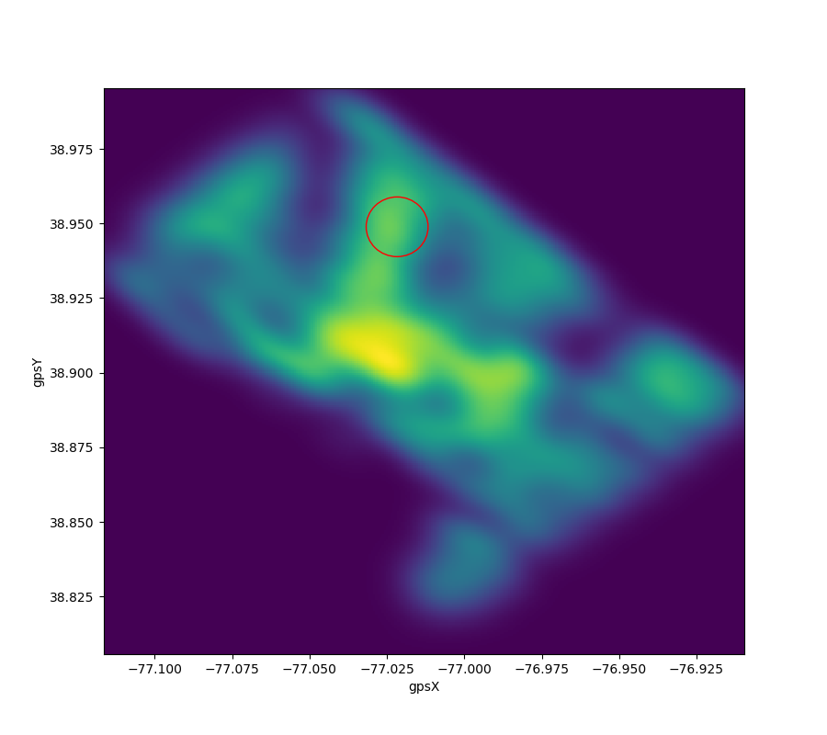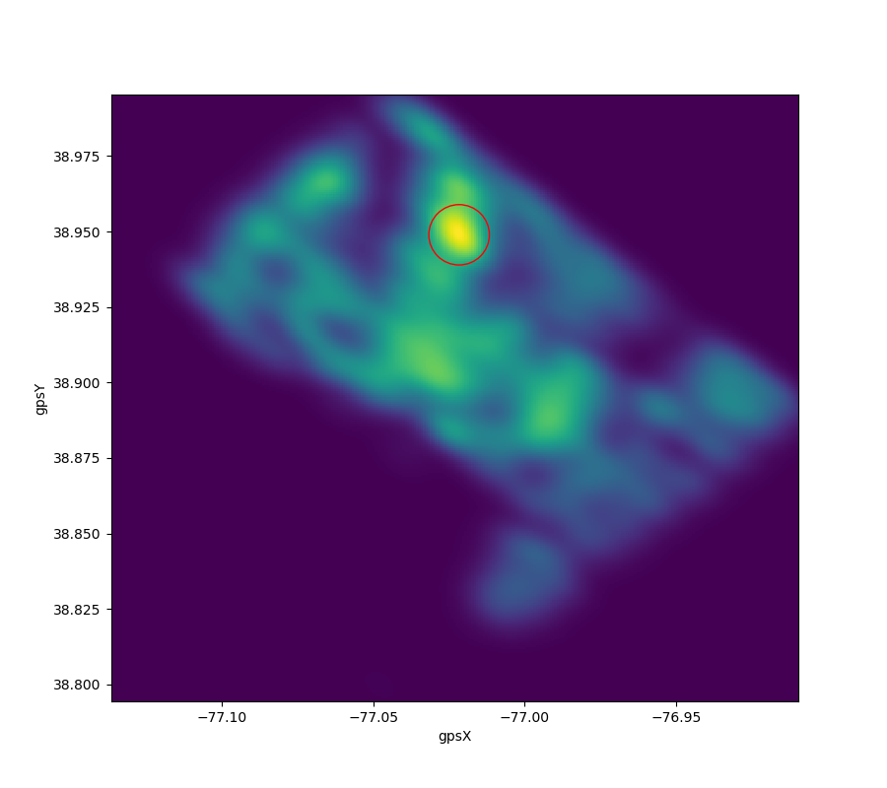

**Recommendations:**

We find that the policy of light replacement is adequate to suppress crime under the assumption that a light outage, if left out for long enough, would increase the probability of a crime occurring. Furthermore under the same previous assumption, it may be possible to extend the allowed deadline for light outage replacement and not impact crime rates if there is an economic justification for doing so. As per our auxiliary finding, we recommend further inquiry into light outages in the areas of BrightWood Park and Petworth. Looking at the data there is not yet a clear reason why such a high density of light outages occurs in this area. Additionally, it may be of interest to consider the seasonal effects of light outages as the data highly implies seasonality effects are significant.